CAPABilities  Statement | - 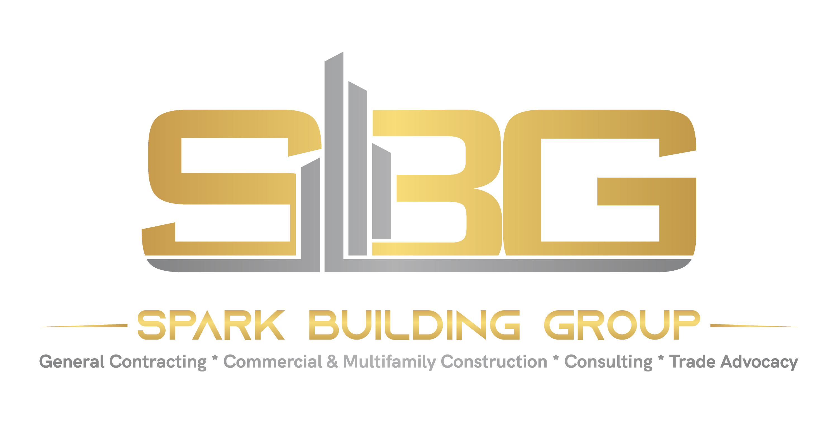  - Licensed Commercial GC + CONSULTANTS – CONCRETE SPECIALTY  - demi@sparkbuildinggroup.com  - Cell: 803.620.5847  - www.sparkbuildinggroup.com
About Spark Building Group  Spark Building Group delivers concrete & storefront projects – initial & repair/maintenance; through subcontractor and prime relationships with the federal government, state & local municipalities in the Southeast; along with prime commercial contractors as second tier subcontractors. SBG helps their clients achieve objectives & project completion through effective project management, GC & subcontracting.  Core Competencies  - Masonry/concrete contractors  - Concrete Paving  - Highway, road, street sidewalk  - Site prep – concrete  - Demolition & waterproofing – concrete  - Storefront  - General management consulting  - Professional management & advanced training  NAICS Codes  Concrete & Storefront: Professional Services:  238150 237310 541611  238110 238910 611430  238140 238390 | Featured Clients  Enterprise Rent-a-Car  Past Performance  - Multiple storefronts  - Asphalt & concrete paving – commercial  - Repair & maintenance  Certifications  - NC DOT SBE & SPSF Cert.  - NC HUB Certified  - NC DOT Prequalified  - NC DOT DBE (submitted)  - SBA 8(a) (submitted)  - NC Certified Lead RRRP  Aspiring:  - Charlotte CBI MWSBE (post-NC HUB return)  DUNS Number: 120882305

